Ideation Phase
Define the Problem Statements

Date | 24 Feb 2026
Team ID | LTVIP2026TMIDS55906
Project Name | Strategic Product Placement Analysis: Unveiling Sales Impact with Tableau Visualization
Maximum Marks | 2 Marks

Customer Problem Statement :
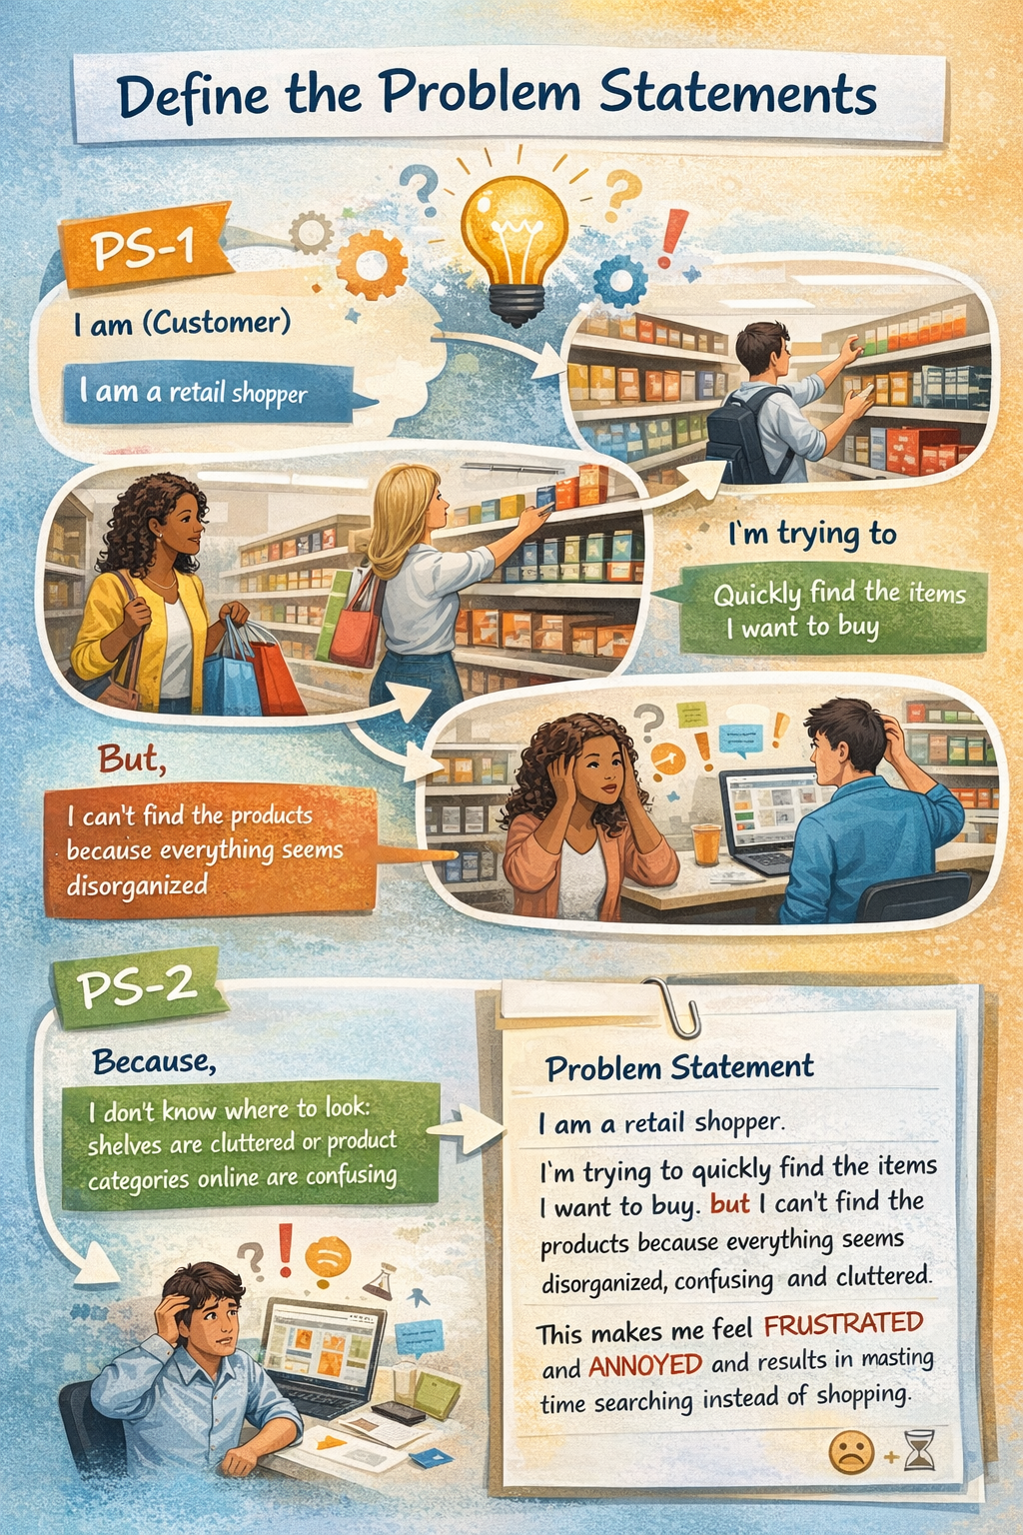
Reference: https://miro.com/templates/customer-problem-statement/

Example:

Problem Statement (PS) | I am (Customer) | I’m trying to | But | Because | Which makes me feel
PS-1 | A retail store manager. | Understand which product placements increase sales. | I can’t identify which shelf or zone performs best. | Sales data is not clearly visualized. | Confused and unable to make effective placement decisions.
PS-2 | A retail business owner. | Improve product visibility and sales. | I don’t know which locations impact customer buying. | There is no dashboard showing placement-based sales insights. | Frustrated and limited in planning store layout.

